

Speaker

Brand Guide

BRAND SCRIPT

As I work with:

Define your ideal audience

What I consistently see:

Describe the challenges
they face

What most people don’t know:

Show us you understand and
can help

Once they…

List the steps for success (your model)

The results are astounding…

Describe the results they can expect

WEBSITE OUTLINE
Things to remember about your website:
1. People don’t read websites, they scan them.
2. Your website should tell a complete story
3. Everything should lead them to either starting a conversation or downloading a high-value resource in exchange for their email address.
Video: Check out this video for how to wireframe your website from start to finish (start at 7:55)
Follow these steps to transfer your brand story into a website.

#1: Create your Website Header
Things to remember about your website Header:
1. It distinguishes you
2. It leaves no doubt what you do and how you do it
3. It includes an action they can take (call you, watch your brand video, learn more etc.)
Steps:
1. Use your distinction statement from your Narrative Clarity
2. Tell the results you will deliver through your services
3. Decide on what buttons to add so the viewer can take an action

WEBSITE HEADER:

Phone # Book _______

LOGO |  |  |  |  |  |  | CONTACT

Write Your Distinction HERE
Write your Promise Statement Here
What action can they take?

Examples:
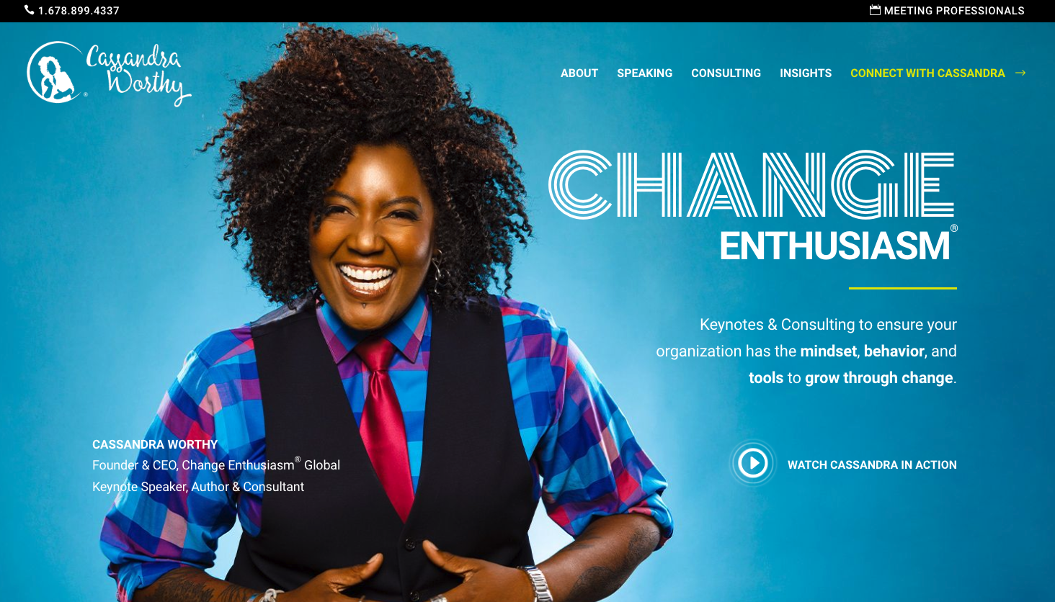

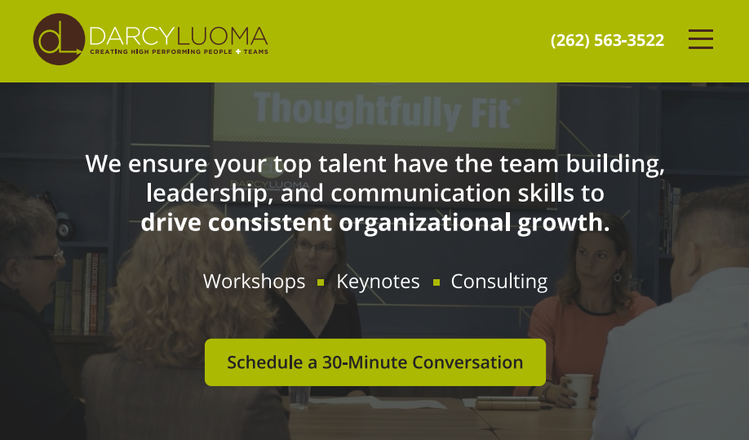

#2: DEFINE THEIR CHALLENGE & YOUR SOLUTION
Help them see you understand the challenge they are facing.
Helpful ways to do this:
- List the most common challenges you hear clients describe to you.
- List the questions they are asking themselves.

Text Here...

Example:
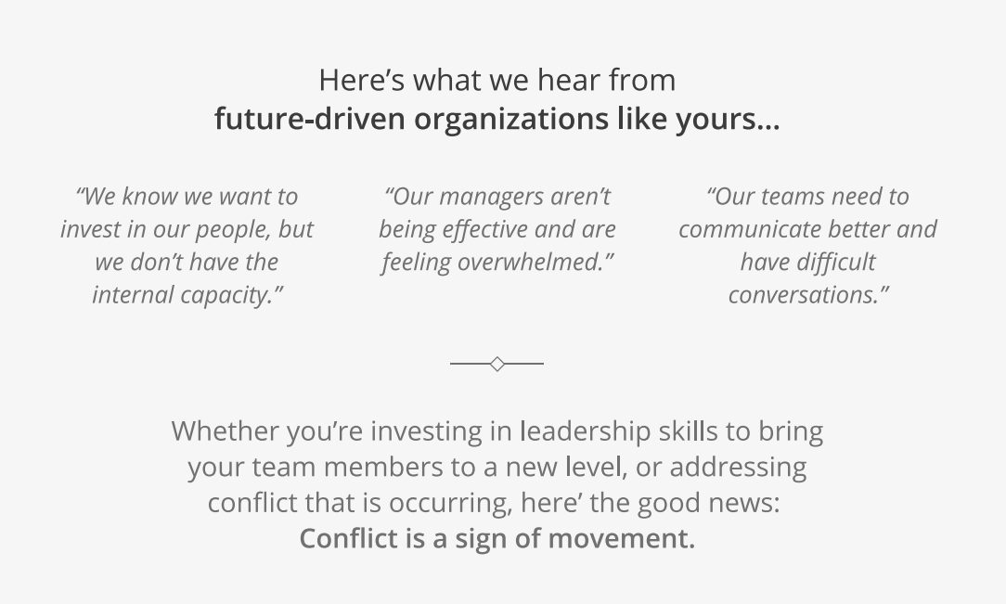

Task #4: Guide
Meet them where they are and show how your story & experience align with what they are facing.
Tell a shortened version of your story that connects to their challenges.
Text Here...

Examples:

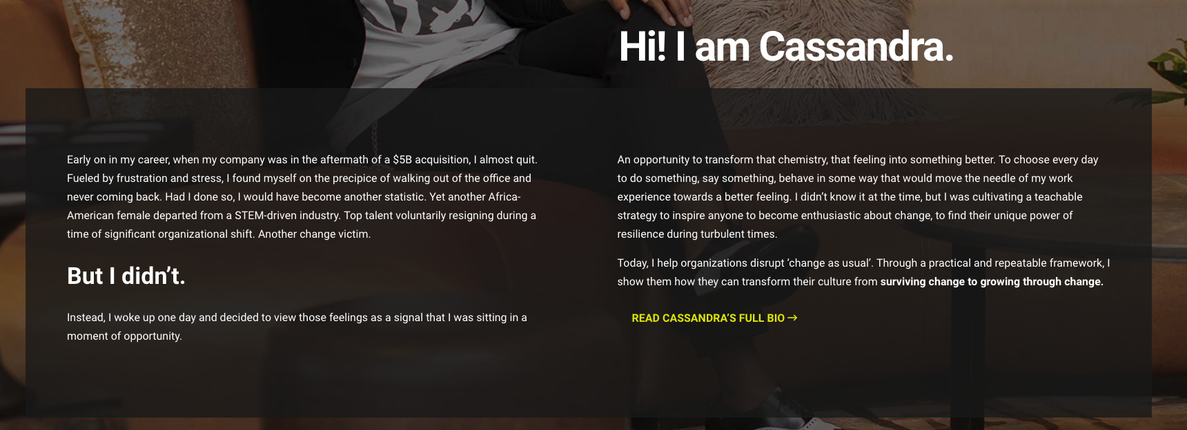

Task #5: Plan
Give them a process they can follow for the results they are looking for.

WRITE YOUR STEPS:
Step 1:  HEADER  Description | Step 2:  HEADER  Description | Step 3:  HEADER  Description

Examples:
#1 - Steps that will lead to their goals
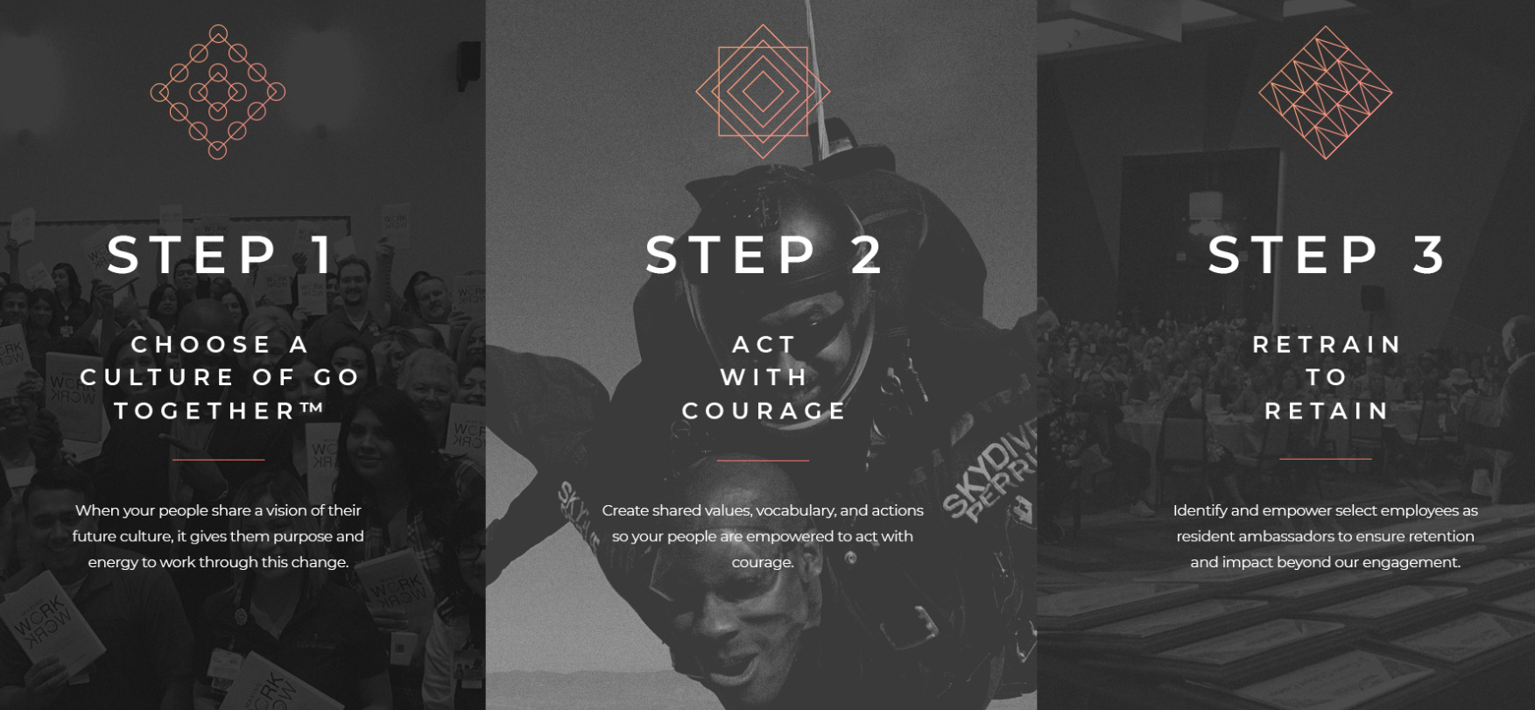

#2 - The way you will work with them before, during, and after the event.
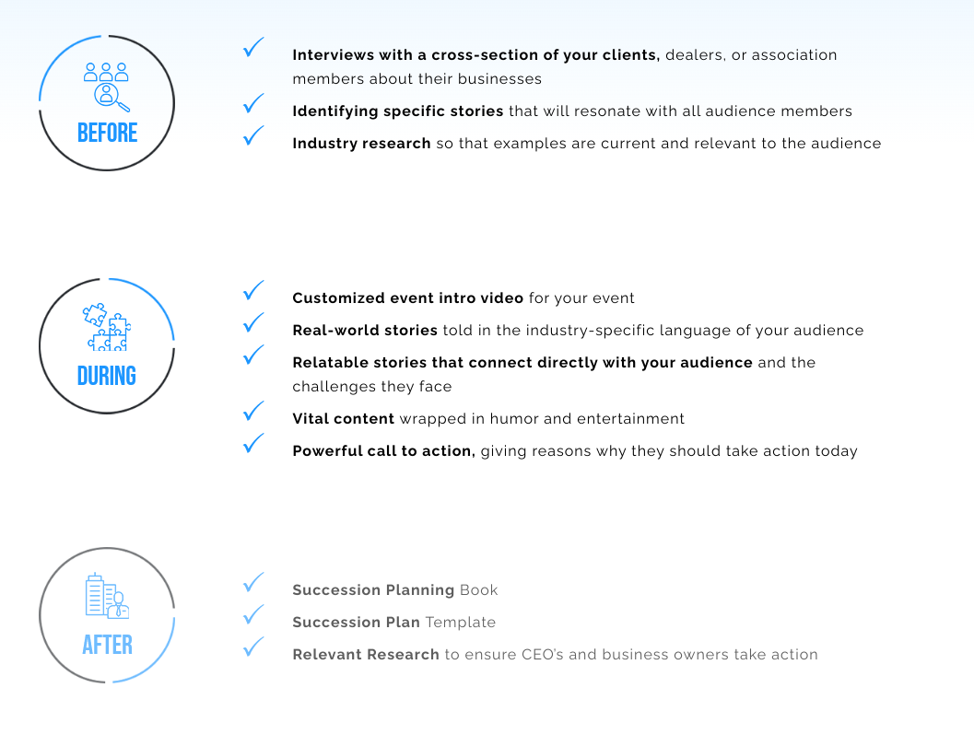

Task #6: Services
List your services as choices.

Service 1: Text Here...
Service 2: Text Here...

Service 3: Text Here...

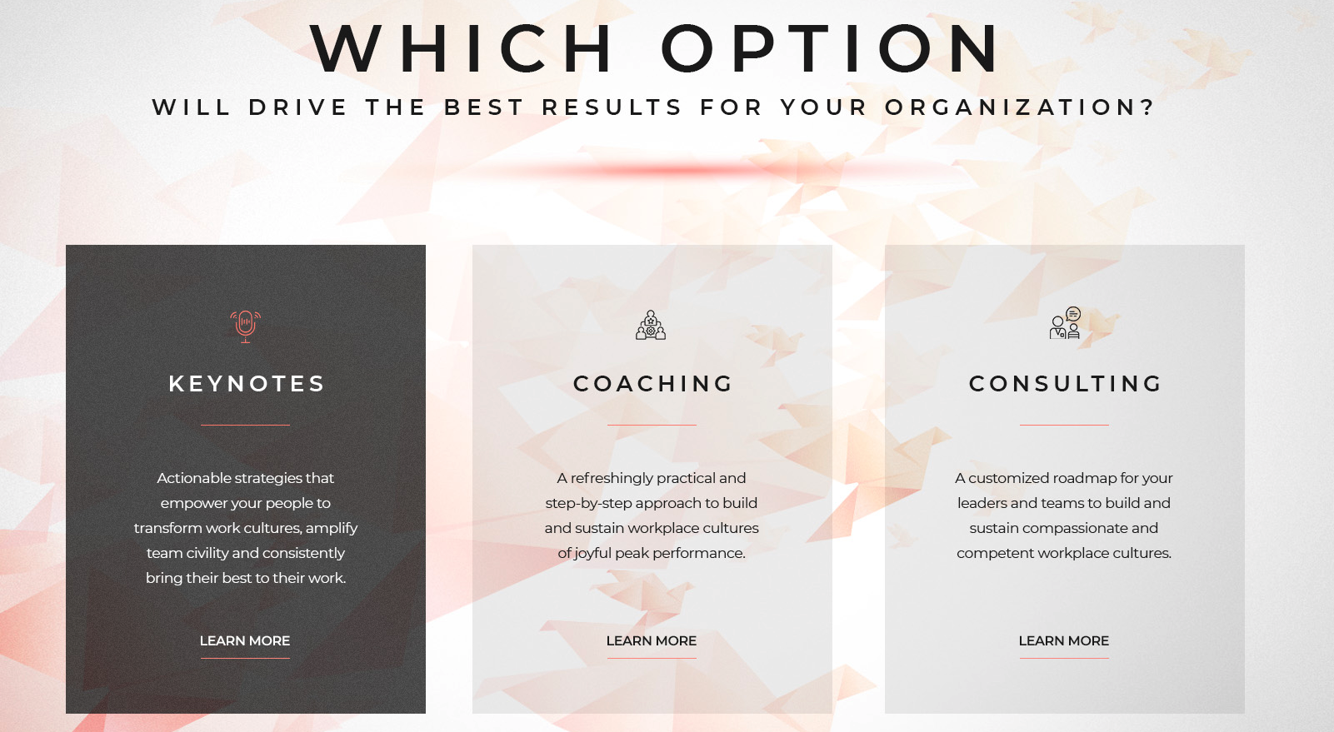

Task #7: Results
Outline the results they can expect from the work.
Prove it with testimonials and/or case studies.
Result 1:  Text Here... | Result 2:  Text Here... | Result 3:  Text Here... | Result 4:  Text Here...

Example:
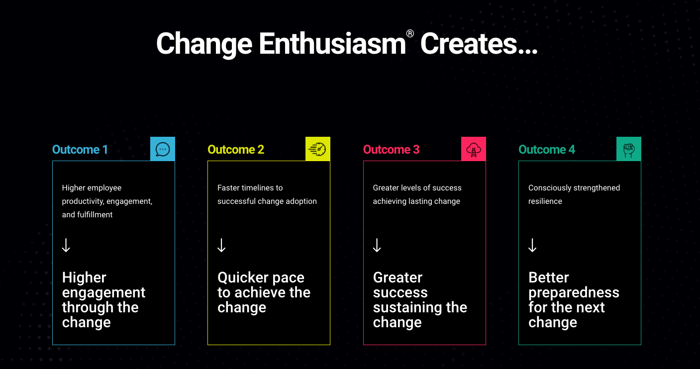

Task #8: Provide Immediate Value:
Offer a high-value way they can learn or take action right away in exchange for their email address.
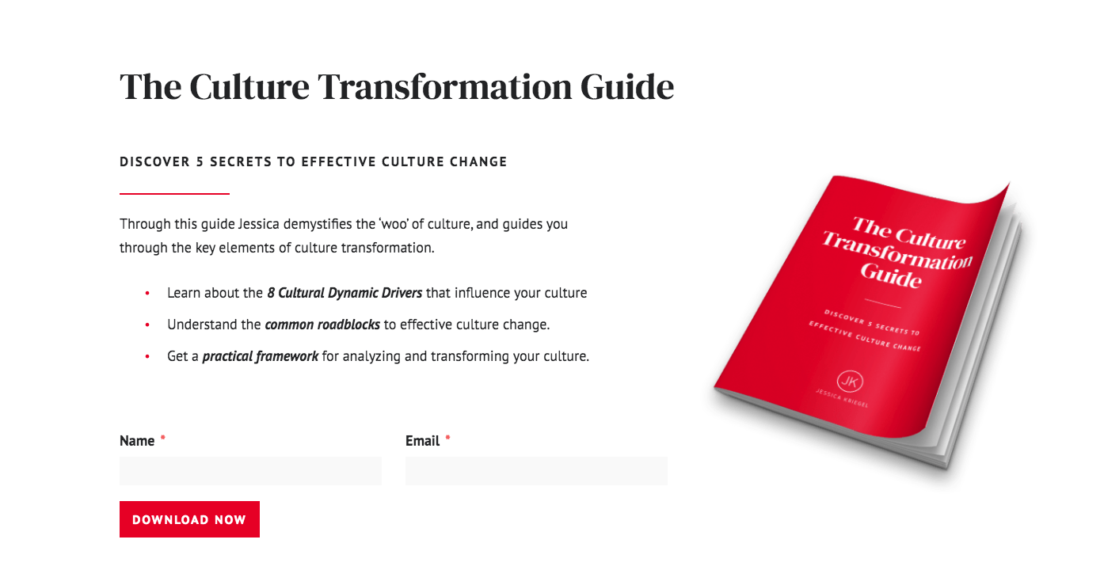

Task #9: Start a conversation:
Make it very easy for them to start a conversation with you.
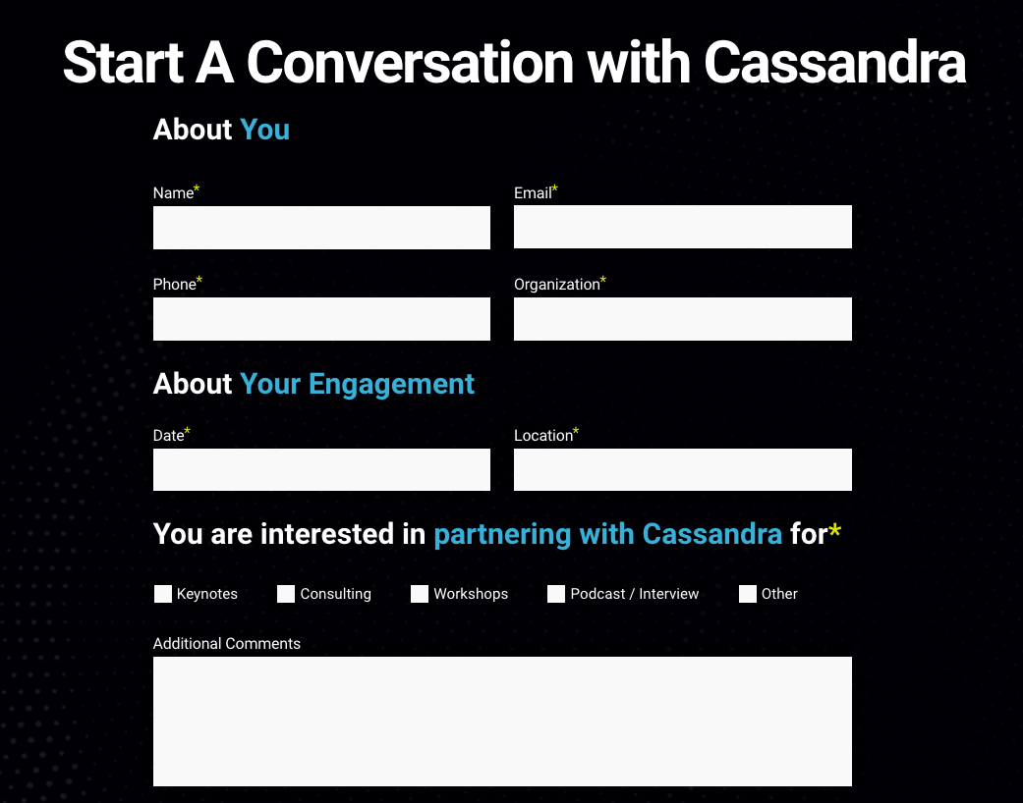

VIDEO SCRIPT

VIDEO EXAMPLE 1 VIDEO EXAMPLE 2 VIDEO EXAMPLE 3

OPENING & INSIGHT | Speak to the challenges they’re experiencing.
Helpful prompts:
Challenge-Based opening:
Today, each of us are experiencing…
Today, we’re living in a world where…
As I travel and work around the country, what I consistently hear is…

Story-based opening:
Start with a date. Drop us into a story.
In 200X…
There was a moment that changed my life, where everything that came after would forever be different…
Idea-Based Opening:
This morning, I want to share an idea with you.
It’s an idea that when implemented will change your life forever.
And that idea is…

INSIGHT & SOLUTION | Help them see what they are missing and your solution to their challenge.
Now, give them insight into their challenge.
Helpful prompt:
What we so often miss is…
What we often fail to realize is…
The reason we’re facing this challenge today is…
Let’s unpack this together so we can see it differently…

GUIDE | Tell your story and give us an overview of the work you’ve done.
Helpful prompts:
This was true of me when I first began this work…
Early on in my career…
I know this is true, because I had the same experience when I…

PLAN | Walk us through the steps for change.
It’s CRUCIAL that you set up your change model effectively.
Here are key lines that work very well:
So, the question is, HOW?
How do we make this change?
So, if we're going to get this right, there's a new way we have to think about it. And it's a process. I call it…
After decades of doing this work, I developed a model…
And the model has three parts…
In our time together, I’m going to take you on a journey.
This journey has X parts…

RESULTS | Show us what will be different in our lives when we get this right.
Finally, tell us the impact this makes in other organizations/people’s lives, or the impact it will make in our lives:
Helpful prompts:
I have seen this create such transformation in organizations. We’ve seen…
What's amazing, is that you will see X result, X result, X result.
When you get this right, you will see remarkable results. You will see…

